**Double-sided marker panel with all indicators**

The 351154 is a marker panel with double-sided printing. The product contains all arrows (left, right, straight on, down) and one blind icon for one-sided marking. You place the desired imprint in the plastic cover and so it is always appropriate for the route to the emergency exit.

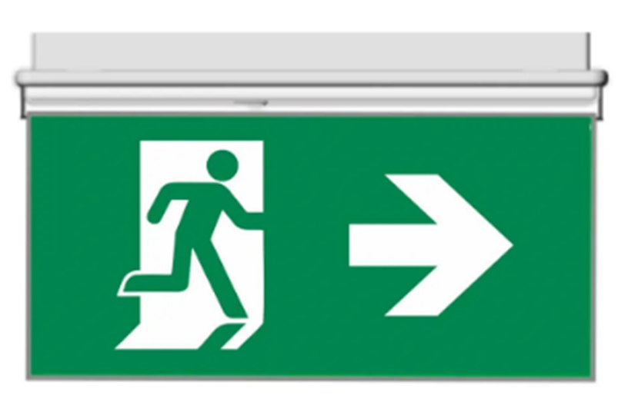

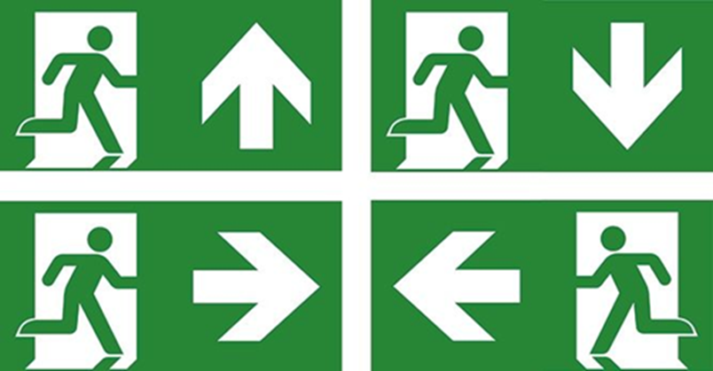

|  |  |
| --- | --- |
| Properties | |
| Material | plastic |
| Weight | 450g |
| Length | 334mm |
| Width | 6mm |
| Height | 159mm |