**double sided marking panel with all indicators/small**

The 351254 is a marker panel with double-sided printing. The product includes all arrows (left, right, straight ahead, down) and one blind icon for one-sided marking. You place the desired imprint in the plastic cover and so it is always appropriate for the route to the emergency exit.

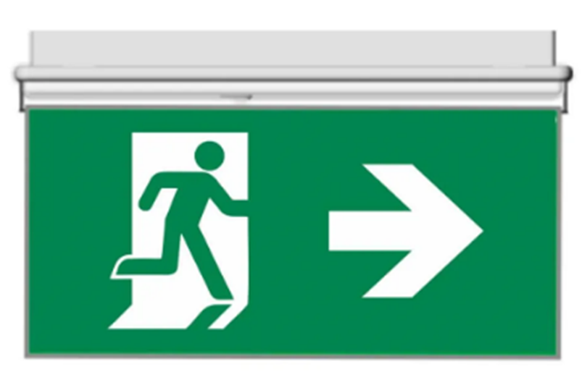

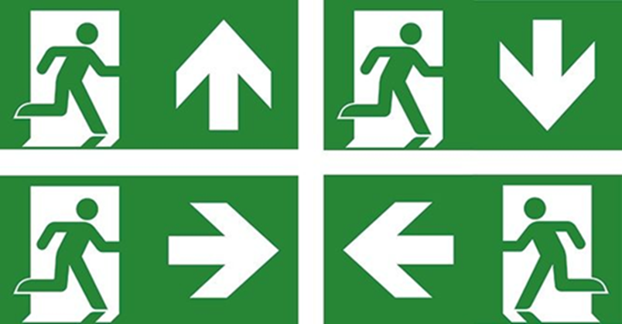

|  |  |
| --- | --- |
| Eigenschappen | |
| Material | plastic |
| Weight | 330g |
| Length | 276mm |
| Width | 5mm |
| Height | 137mm |