GVIC-B3202.8.3.240726

Release Notes

Zhejiang Uniview Technologies Co., Ltd.

Keywords: release introduction, restrictions and precautions, important updates, version installation and upgrade guide

Abstract: This document describes the release reason, restrictions, known defects, and problems solved of the version.

Abbreviations

|  |  |
| --- | --- |
| Abbreviation | Full Spelling |
| FTP | File Transfer Protocol |

Contents

1 Version Info 3

1.1 Versions and Release Reasons 3

1.2 Version Mapping 3

2 Version Change Description 3

2.1 Version Updates 3

3 Version Precautions 4

3.1 Precautions 4

3.2 Upgrade Overview 4

3.3 Software Upgrade on the Webpage 5

3.4 Upgrade Using SSH2 6

3.4.1 Network Topology for Upgrade Using SSH2 6

3.4.2 Procedure for Upgrade Using SSH2 7

3.5 Troubleshooting 7

4 Version Upgrade Disclaimer 7

# Version Info

## Versions and Release Reasons

Versions and Release Reasons

|  |  |  |  |
| --- | --- | --- | --- |
| Customer Version Number | Basic Version Number | Date | Release Reason |
| GVIC-B3202.8.3.240726 | GVICV300R002B02D008SP03 | 2024-07-26 | For technical support personnel、Limited release |

## Version Mapping

Mapping Table

|  |  |  |  |
| --- | --- | --- | --- |
| Products & Models | Customer Version Number | Historical Mapping | Remarks |
| OEI-372S-H-W、OEI-372S-H-W –NB、OEI-372S-H-W-Z、OEI-372S-H-W-Z-NB | GVIC-B3202.8.3.240726 |  | None |

# Version Change Description

|  |  |
| --- | --- |
| business | Description |
| Add modification points and issues | D008:  AA14788 【Priority 2 Hint Conditionally Reproducible】For EI-371S indoor unit, it is recommended that the device switch on the door station page be set to default on.  QPTSD36057 【Priority 2 General Indoor Unit Occasional】Overseas indoor units frequently register with YI Cloud for about 1000 times, leading to device SIG11 crashes.  QPTSD36166 【Priority 1 Serious Always Reproducible】The cloud currently does not accommodate the CancelOther signaling, causing abnormal disconnection of the APP.  QPTSD36214 【Priority 1 General Overseas Indoor Unit Always Reproducible】After a call between the main and extension units of an indoor unit, if the call is answered immediately before the first beep, the caller's unit still has a continuous "beep" sound.  QPTSD36215 【Priority 2 General Indoor Unit Always Reproducible】When extension numbers are the same for different extensions, the devices are forcibly changed to the same IP.  QPTSD36217 【Priority 1 General Indoor Unit Always Reproducible】In the auto-answer mode of the main unit, the tone indicating the extension unit is busy is too low.  QPTSD36223 【Priority 1 General Overseas Indoor Unit Always Reproducible】For overseas indoor units: the "-" key for guest message volume is not grayed out by default; optimization needed for the display in the WiFi input field; no password required or pop-up for confirmation when deleting a device under the detection interface, which could lead to accidental operations; add prompts; the WiFi search prompt does not automatically close after WiFi search is complete.  QPTSD36226 【Priority 2 General Time Zone Configuration Always Reproducible】When configuring the time zone, the time does not change immediately until it is refreshed.  QPTSD36231 【Priority 1 Hint Always Reproducible】Usability: when changing the extension number of an indoor unit to "0", the system prompts "extension number cannot be 0", and when changing to 20, the system prompts "extension number is invalid, valid range is 0-19", which is contradictory.  QPTSD36232 【Priority 1 General Overseas Indoor Unit Always Reproducible】Mutual deletion between master and slave units, synchronize both sides.  QPTSD36236 【Priority 1 General Indoor Unit Always Reproducible】Under password mode, there is an issue with display offset in some scenarios.  QPTSD36237 【Priority 1 Serious Overseas Indoor Unit Always Reproducible】For the first IPC added, subsequent addition of more than 6 IPCs, the IPC tab (6 devices per tab) in the monitoring interface cannot be switched, need to switch to the door station tab and then switch back to the camera to have the tab switching button.  QPTSD36242 【Priority 1 Serious Overseas Indoor Unit Occasional】During burn-in testing, frequent calls between the door station and indoor unit, randomly entering guest message or indoor unit answer service, leads to freezing on the call interface and device freeze.  QPTSD36251 【Priority 1 General Overseas Indoor Unit Always Reproducible】When switching from slave to master unit, default call duration should be changed to 60s; when switching from master to slave unit, call duration should be 65s, and default value should also be changed to 65s.  QPTSD36262 【Priority 2 General Domestic Indoor Unit Always Reproducible】Optimization of IP address configuration for domestic indoor units.  QPTSD36266 【Priority 1 Serious Indoor Unit Always Reproducible】Screenshot function for monitoring and call records fails when full coverage is reached.  QPTSD36267 【Priority 1 General Overseas Indoor Unit Always Reproducible】When switching from master to slave unit, if there are unread guest message notifications, the number of unread notifications remains after switching to the slave unit.  QPTSD36370 【Priority 1 Serious Always Reproducible】During audio intercom between door station and indoor unit, the sound on the indoor unit side is small when the door station speaks, requiring one to be within about 20cm to hear, and there are intermittent sound issues.  QPTSD36395 【Priority 1 Requirement Indoor Unit】Interlinking of auto-answer and APP and guest message (auto-answer automatically transfers to guest message).  AA04002 【Version Verification Issue Serious Conditionally Probable Reproducible】Failure of indoor unit to synchronize system time with door station.  AA04014 【Version Verification Issue Critical Conditionally Always Reproducible】Upon reboot of the indoor unit, synchronization of system time with the door station triggers the timer for timed reboot, leading to device reboot.  AA04127 【Priority 1 Serious Master-Slave Binding Always Reproducible】Binding of the extension unit to the main unit of the indoor unit, prompts "save failed", but the actual binding relationship is successfully issued.  AA04129 【Priority 1 Serious Call Always Reproducible】For SP02 door station with older version indoor unit, when the door station calls the main or extension unit of the indoor unit, if indoor unit A hangs up, indoor unit B does not automatically hang up.  AA04206 【Priority 1 Serious Always Reproducible】In multi-call networking, when the indoor unit is bound to the APP: door station 1 calls APP1 and is answered, when door station 1 clicks to hang up after about 2 seconds, the real-time monitoring interface of the main indoor unit, the monitoring interface must show a black screen.  AA04385 【Serious Domestic Indoor Unit Occasional】For domestic push-button indoor units, there is an issue where the login password becomes invalid, resulting in password error prompts when using the previously set password on the human-machine interface level 2 and the WEB interface.  AA04766 【Serious Overseas Indoor Unit Conditionally Always Reproducible】Optimization of touch screen testing, currently divided into 7*8, it is expected to be optimized to 14*16, increase resolution; when interfacing with the project, the long-term expectation is changed to 60s.  AA05699 【Priority 2 Serious Overseas Indoor Unit Conditionally Always Reproducible】It is recommended to optimize the indoor unit log recording scheme, currently, the log recording strategy cannot collect the required logs well when issues are discovered, making it difficult to pinpoint the problem.  AA06127 【Priority 1 Serious Overseas Indoor Unit Conditionally Probable Reproducible】During burn-in testing, when the indoor unit is in the process of calling and leaving a guest message, frequent turning on/off of recording leads to device freeze.  AA06833 【Priority 1 Serious Domestic Indoor Unit Conditionally Probable Reproducible】After bp componentization, if there is a bp blockage, it can lead to the infinite expansion of the Slab_Keyinfo.log log file, filling up the device's /tmp path, reducing memory, and making the device sluggish.  AA07726 【Priority 2 General Conditionally Always Reproducible】For some language interfaces of the indoor unit, the position of the unread guest message notification dot is incorrect.  AA08502 【Companion Test Indoor Unit Video Intercom Serious Occasional】For apartment door stations - indoor units - cloud - UNVLink networking, a high probability exists that there is no video call alarm information on UNV-Link when answering, not answering, or hanging up.  AA08518 【Priority 2 Serious Overseas Indoor Unit Network Monitoring Conditionally Always Reproducible】After the main indoor unit receives a network disconnection warning during monitoring, when an extension calls the main unit, the main unit cannot hang up after answering.  AA10251 【Priority 1 Serious Conditionally Always Reproducible】When switching the indoor unit from a static address to a dynamic address, the first save will fail.  AA10314 【Priority 1 Serious Domestic Indoor Unit Conditionally Always Reproducible】For master-slave + access control networking, when the access control changes to a non-East 8 time zone, the main unit syncs the time from the access control and then syncs time with the slave units, after about five minutes, both the main and slave units will reboot.  AA12471 【Priority 1 One-to-Many Serious Conditionally Always Reproducible】When slabfull occurs, the slab_keyinfo log file will become unlimitedly large.  AA12699 【Priority 1 Serious Conditionally Probable Reproducible】Repeating header files for indoor units are eliminated by pc-lint, logs for the video intercom process are added.  AA13257 【Priority 2 General Conditionally Always Reproducible】Overseas indoor unit adaptation of YI Cloud component.  AA13528 【Priority 1 Serious Neighbor-to-Neighbor Conditionally Probable Reproducible】Under neighbor-to-neighbor networking, when one indoor unit calls another, and one party answers while the other hangs up, one party remains on the call interface, while the other returns to the home screen and the volume changes to the call gain effect.  AA13529 【Priority 1 General Conditionally Always Reproducible】When resident A is in a call, resident B calls resident A, the interface of resident B's device prompts no answer and does not automatically hang up or return to the home screen.  AA13767 【Priority 1 Serious Conditionally Always Reproducible】After using EZtools to issue the binding relationship, the OutdoorInfo table in the indoor unit stores empty access control location information, then it needs to be rebound on the human-machine interface to refresh.  AA13950 【Priority 2 Hint Conditionally Always Reproducible】For EI-371S indoor unit, it is recommended that the device switch on the door station page be set to default on.  AA02376 【Requirement Serious Conditionally Always Reproducible】After a major recovery of the indoor unit, historical logs still exist and are not deleted.  AA02549 【Priority 2 Serious Occasional】During mutual calls between the main and extension units of the indoor unit, after the answering party hangs up, there is an issue where the key tone becomes louder, which is quite loud and a bit harsh on the ears. Verification with a mobile decibel meter shows a difference of 2-4db from normal sound.  AA02627 【Priority 1 General Always Reproducible】After the indoor unit successfully modifies the extension number of the one-to-one villa door station, when querying the Indoor/OutdoorInfo interface of the indoor unit/LAPI/V1.0, the extension number has not changed, and it needs to reissue the binding relationship to successfully sync.  AA02933 【Serious Domestic Indoor Unit Occasional】For domestic push-button indoor units, there is an issue where the login password becomes invalid, resulting in password error prompts when using the previously set password on the human-machine interface level 2 and the WEB interface.  AA02948 【Priority 1 Serious Call Always Reproducible】Requirement: addition of a multi-call solution for one-to-one door stations.  D008SP01:  AA17963 【Priority 1 Serious Overseas Indoor Unit Conditionally Always Reproducible】For master-slave + door station networking, when the main unit has auto-answer and guest message enabled, if the master and slave units simultaneously monitor the door station, when the door station calls, the main unit does not enter the message state.  AA18725 【Priority 1 Serious Conditionally Always Reproducible】Compilation failure of domestic indoor units (introduction of YI Cloud component adaptation for overseas indoor units).  AA18733 【Priority 1 Serious Conditionally Always Reproducible】After a major recovery of white-label overseas indoor units, the cloud server address becomes the domestic cloud.  AA19496 【Priority 1 Serious Conditionally Always Reproducible】During reverse calls, screenshot failure is always present.  AA19804 【Priority 1 General Overseas Indoor Unit Conditionally Always Reproducible】Local compilation of the driver fails to find the header file.  AA19803 【Priority 1 Serious Overseas Indoor Unit Conditionally Always Reproducible】When the indoor unit is connected to the router's WiFi and wired network, both are in the same network segment, call failure occurs.  AA20019 【Priority 1 Serious Conditionally Always Reproducible】Requirement: adaptation of Agora feature functions.  AA20463 【Priority 2 General Conditionally Always Reproducible】Error in the YI Cloud term on the human-machine interface of the indoor unit, Ezcloud should be EZCloud.  AA21290 【Priority 1 Serious Overseas Indoor Unit Conditionally Always Reproducible】When the indoor unit is connected to the router's WiFi and wired network, both are in the same network segment, call failure occurs.  AA09050 【Priority 3 General Conditionally Always Reproducible】Third-party libraries do not have soft links established, occupying 2MB+ of storage space.  AA15317 【Priority 2 General Conditionally Always Reproducible】Error in the YI Cloud term on the human-machine interface of the indoor unit, Ezcloud should be EZCloud.  AA16379 {VIC V300R002B03}{0235C7S2}{Mass Production Software Issue}{0501C2VT_B3201.7.1.LJ01} Under no touch screen contact or damaged touch screen conditions, after the device starts, the human-machine interface is not displayed on the monitor, please analyze and solve.  D008SP02:  AA23813 【Priority 1 Serious Australia S Conditionally Probable Reproducible】When the APP manually refreshes the page or the device goes online, triggering the cloud upgrade LAPI interface query, the LAPI service is blocked, leading to abnormal sending and receiving of door station signaling, resulting in call state confusion.  AA24432 【Priority 1 General Conditionally Always Reproducible】Error in the logout term of brand/white-label indoor units from YI Cloud/P2P, Ezcloud should be EZCloud/P2P.  AA24585 【Priority 1 Serious Conditionally Probable Reproducible】For the Australia S version: in group call mode, when the door station calls, the main indoor unit answers, currently, when speaking on the main indoor unit side, there is no sound on the door station side, requiring a reboot to restore.  AA24768 【Priority 1 Companion Test Video Intercom Serious Always Reproducible】For door station - indoor unit - UNV Link networking, when the indoor unit on APP1 is shared with APP2, when the door station calls, both APPs receive the call, after one APP answers, the other APP does not automatically hang up (normal hang-up for the indoor unit).  AA24801 【Priority 1 Serious Overseas Indoor Unit Conditionally Always Reproducible】When door station A calls and APP1 answers, APP2 does not hang up, and after APP2 clicks to hang up, it terminates the call state of APP1, at this point, door station A can only call the extension, the main unit monitoring door station AB and calling the extension all display Busy, the APP cannot monitor.  D008SP03:  AA22946 【Priority 1 General Conditionally Always Reproducible】Mainline adaptation for Z indoor unit.  AA26870 【Priority 1 General Conditionally Always Reproducible】Mainline adaptation for Z indoor unit. |

# Version Precautions

## Precautions

### Legacy problem

## Upgrade Overview

Version File Composition

|  |  |  |
| --- | --- | --- |
| Compressed Upgrade Package | File | File Description |
| GVIC-B3202.8.3.240726.zip | uimage.bin | Kernel + root file system image |
| program.bin | Application software |
| VERSION_uboot | Version information containing u-boot |
| u-boot.bin | U-boot image |
| matchtable.csv | Version information configuration table |
| VERSION | Version information |
| verinfo.ver | Customer version information |

**I. Version Upgrade Modes**

Currently, a version can be upgraded by using the webpage or SSH2.

注意CAUTION!

1. When upgrade on the webpage fails, SSH2 can be used.

2. For upgrade using SSH2, the FTP software needs to be used. For details of the software, see section 4.3.

3. Upgrade through WEB/SSH2 involves uimage.bin, program.bin, and VERSION.

**II. Preparations for Upgrade**

1. Decompress the version file (GVIC-B3202.8.3.240726.zip) to the same directory as the version file. The figure below shows the content of the directory after the decompression.

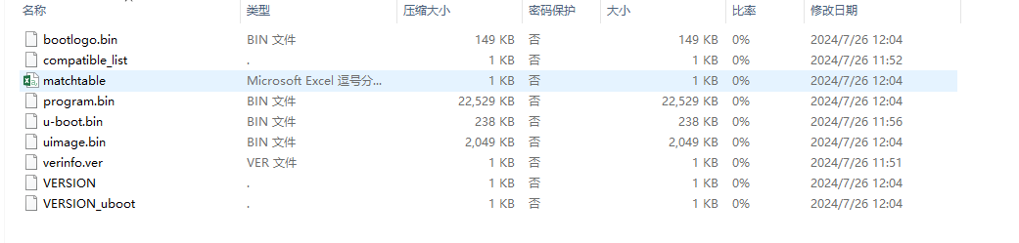

2. For upgrade on the webpage, select the compressed version package. For upgrade through SSH2, set the FTP server path to the folder of the decompressed version installation package.

## Software Upgrade on the Webpage

1. Log on to the webpage as the admin user (default password: 123456).

2. Choose **System** > **Maintenance**.

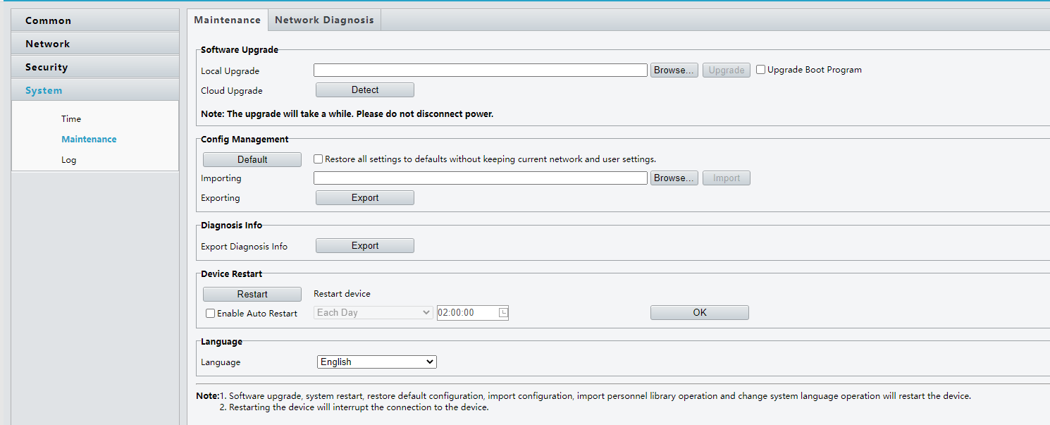

3. Click the **Browse** button on the **Software Upgrade** module, select the desired version file package (GVIC-B3202.8.3.240726.zip) in the displayed file loading window, and click **OK** to return to the software upgrade page.

4. After the **Upgrade** button becomes available, click it to start upgrade. During the upgrade, other operations are unavailable on the page.

5. After successful upgrade, the system displays "Upgrade succeeded. Please log in again after restart."

## Upgrade Using SSH2

注意CAUTION!

1. If upgrade on the webpage is available, this mode is not recommended.

2. For upgrade through SSH2, FTP needs to be installed on the PC.

**FTP Introduction**

The File Transfer Protocol (FTP) is used for file transfer on the Internet. The FTP server software provides storage space on the Internet and supplies services in FTP. The FTP client software downloads files from or uploads files to an FTP server in FTP.

The PC needs to be installed with FTP server.

Connect the device LAN port and the PC by using a crossover Ethernet cable. Start the FTP program on the PC as the server, enable anonymous user login, and set the FTP server path to the directory of the version file.

注意CAUTION!

1. The FTP server needs to be purchased and installed by the customer, and the software is not provided with the device.

### Network Topology for Upgrade Using SSH2

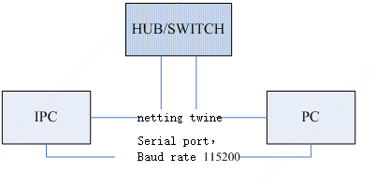

As shown in the figure above, the version file is saved on the PC that can provide FTP services, and the PC and the device are connected on the network.

### Procedure for Upgrade Using SSH2

1. Set the FTP server on the PC, and confirm that the network communication between the PC and the device to be upgraded is normal. (In this section, the device IP address is 192.168.0.13, and the PC IP address can be set to 192.168.0.5.)

2. Log in to the device using SSH2 (username: root; password: 123456).

3. Perform upgrade:

**user@/root>: update 192.168.0.5 all -f**

4. After the upgrade, the device automatically restarts. Do not perform any operation during this process to complete the upgrade.

## Troubleshooting

**Power failure during the upgrade or startup failure after the upgrade**

1. If you can connect to the device through SSH2 or the serial port, perform upgrade again.

2. If the failure persists after the upgrade, seek help from the sales or service personnel.

3. If you cannot connect to the device through SSH2 or the serial port, seek help from the sales or service personnel.

# Version Upgrade Disclaimer

|  |
| --- |
| **UNV Version Upgrade Disclaimer** |
| 1. By setting or installing this program in any way you agree to all of the following terms and conditions. Your downloading or using the program means you acknowledge your full understanding and acceptance of the following terms and conditions. If you do not agree to any of the following terms, you shall not use the program and you must cease installing and delete the program immediately.  2. The upgrade program is only applicable to the intended regions and product models. Before upgrade or update, please read the release notes carefully to make sure the program is applicable to your region and product model. You will be fully liable and responsible for all the consequences of device abnormality and related maintenance costs caused by your improper operations.  3. Uniview owns or is legally authorized to own all rights and IPRs (Intellectual Property Rights) of the program and the supplied release notes.  4. Software upgrades are for the optimization of product functions and do not mean there is defect.  5. You must strictly follow instructions in the release notes during the upgrade process, otherwise you are responsible for the possible consequences and related maintenance costs.  6. You shall not engage in any of the following activities, otherwise you would be liable for infringement and responsible for any adverse consequences arising therefrom.  6.1 Copy the program (exclude the reasonable and necessary copies for internal backups);  6.2 Exclude this statement when using the program or transfer the program to any third party;  6.3 Modify the program or its derivatives;  6.4 Reverse engineer, decompile or disassemble this program.  7. The program is only intended for authorized users. Its architecture, organization and source code are valuable trade secrets and confidential information owned by Uniview and its authorized parties. You agree not to provide or disclose any confidential information contained in or derived from the software to any third party. No part of this document may be excerpted, reproduced, or distributed in any form by any entity or individual without written consent from our company. |